1. Download postgres database and install.

<https://www.enterprisedb.com/downloads/postgres-postgresql-downloads>

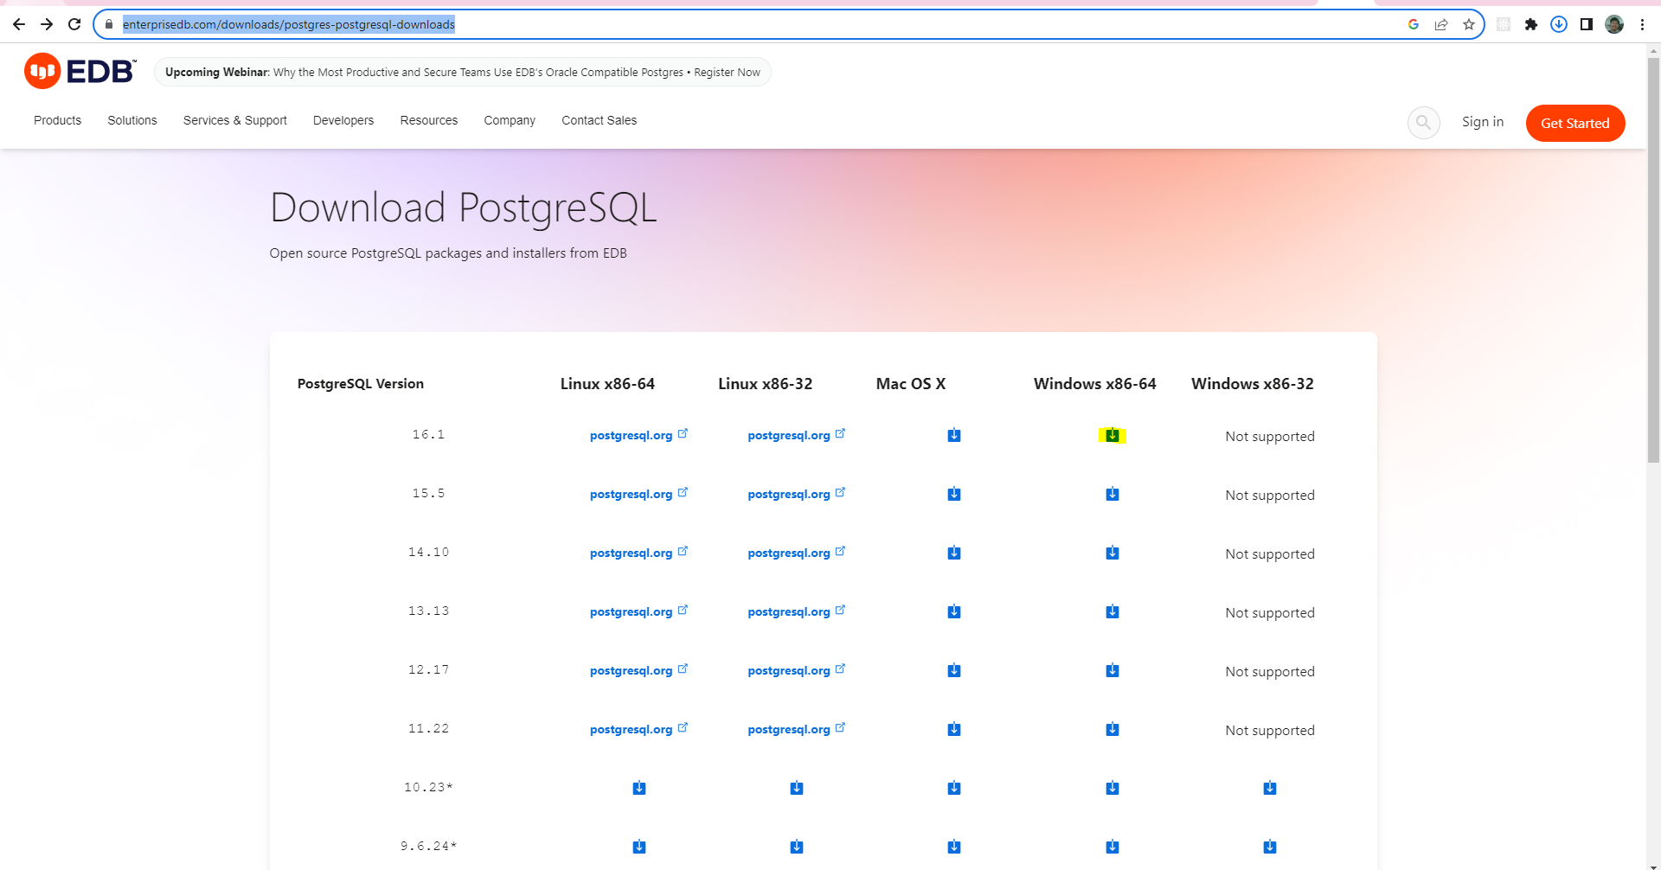

2. Download dbeaver.

https://dbeaver.io/download/

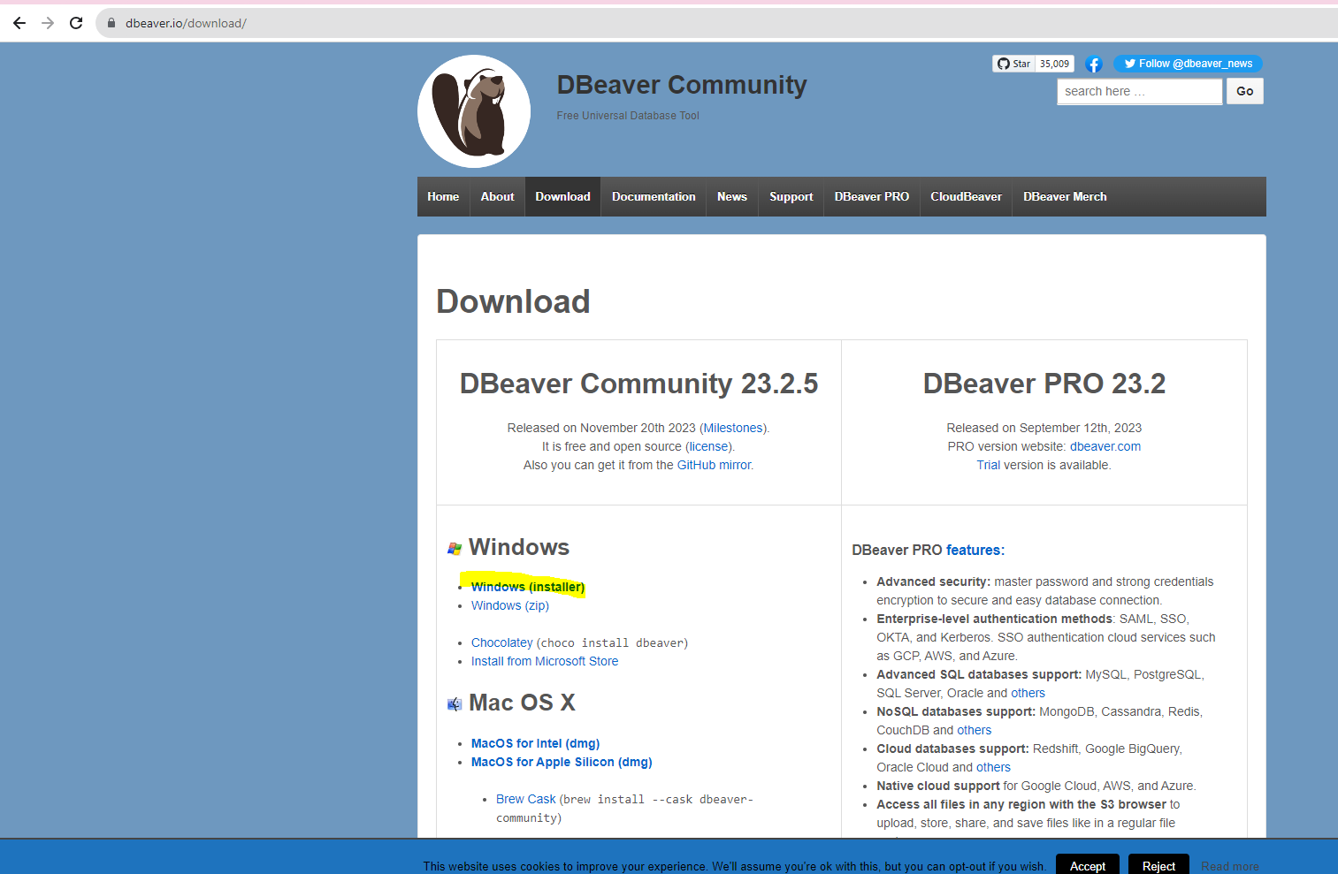

3. Launch dbeaver and create new postgres database instance and schema.

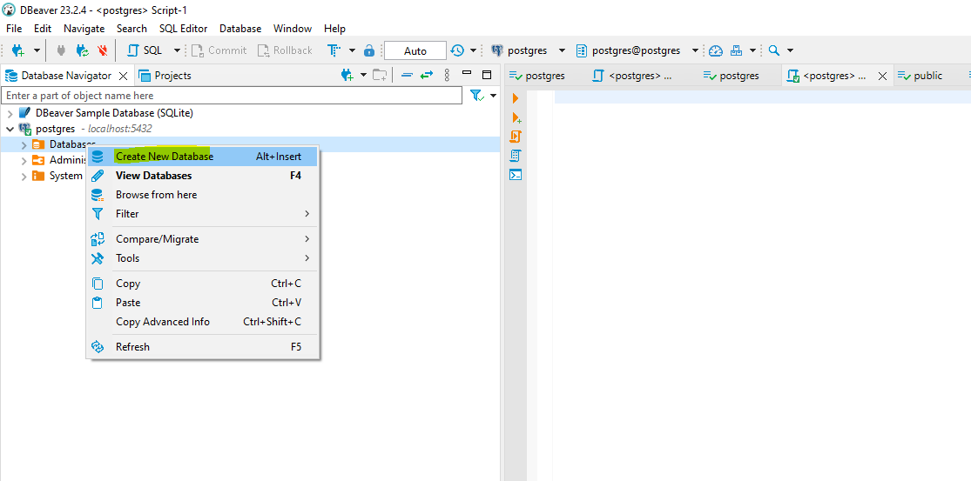

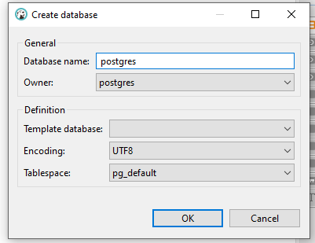

Create new schema

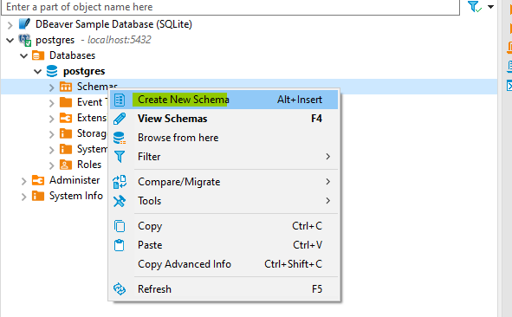

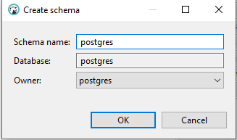

spring.datasource.url= jdbc:postgresql://localhost:5432/postgres  
spring.datasource.username=postgres  
spring.datasource.password=password

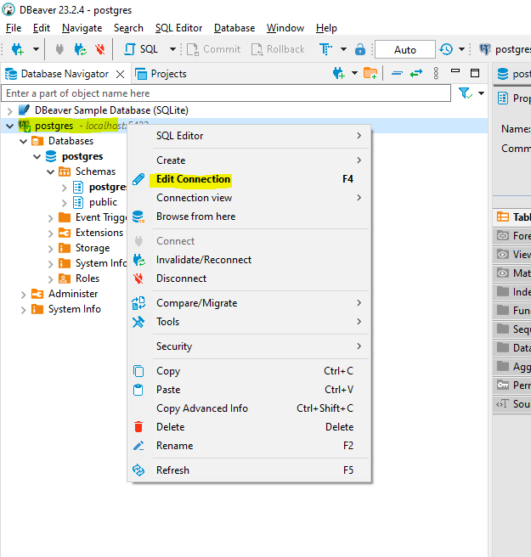

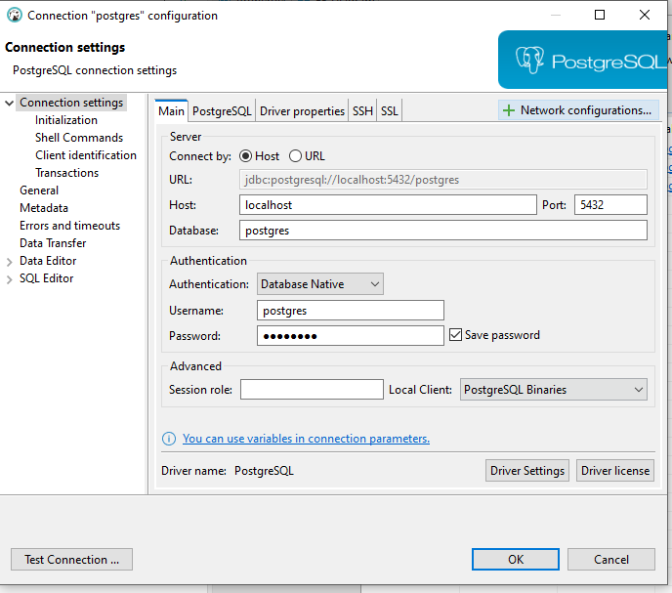

Database information in application.properties

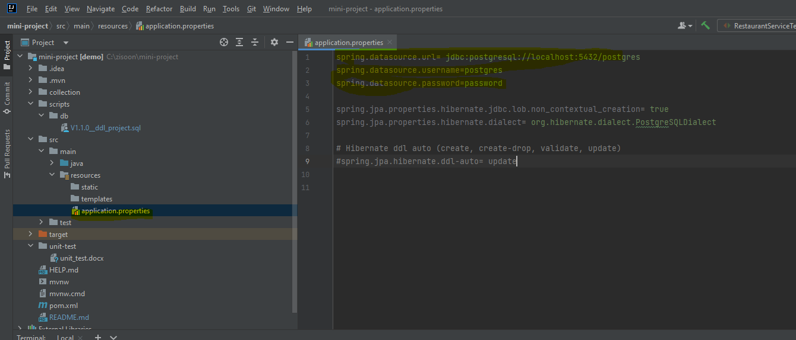

4. Download postman.

https://www.postman.com/downloads/

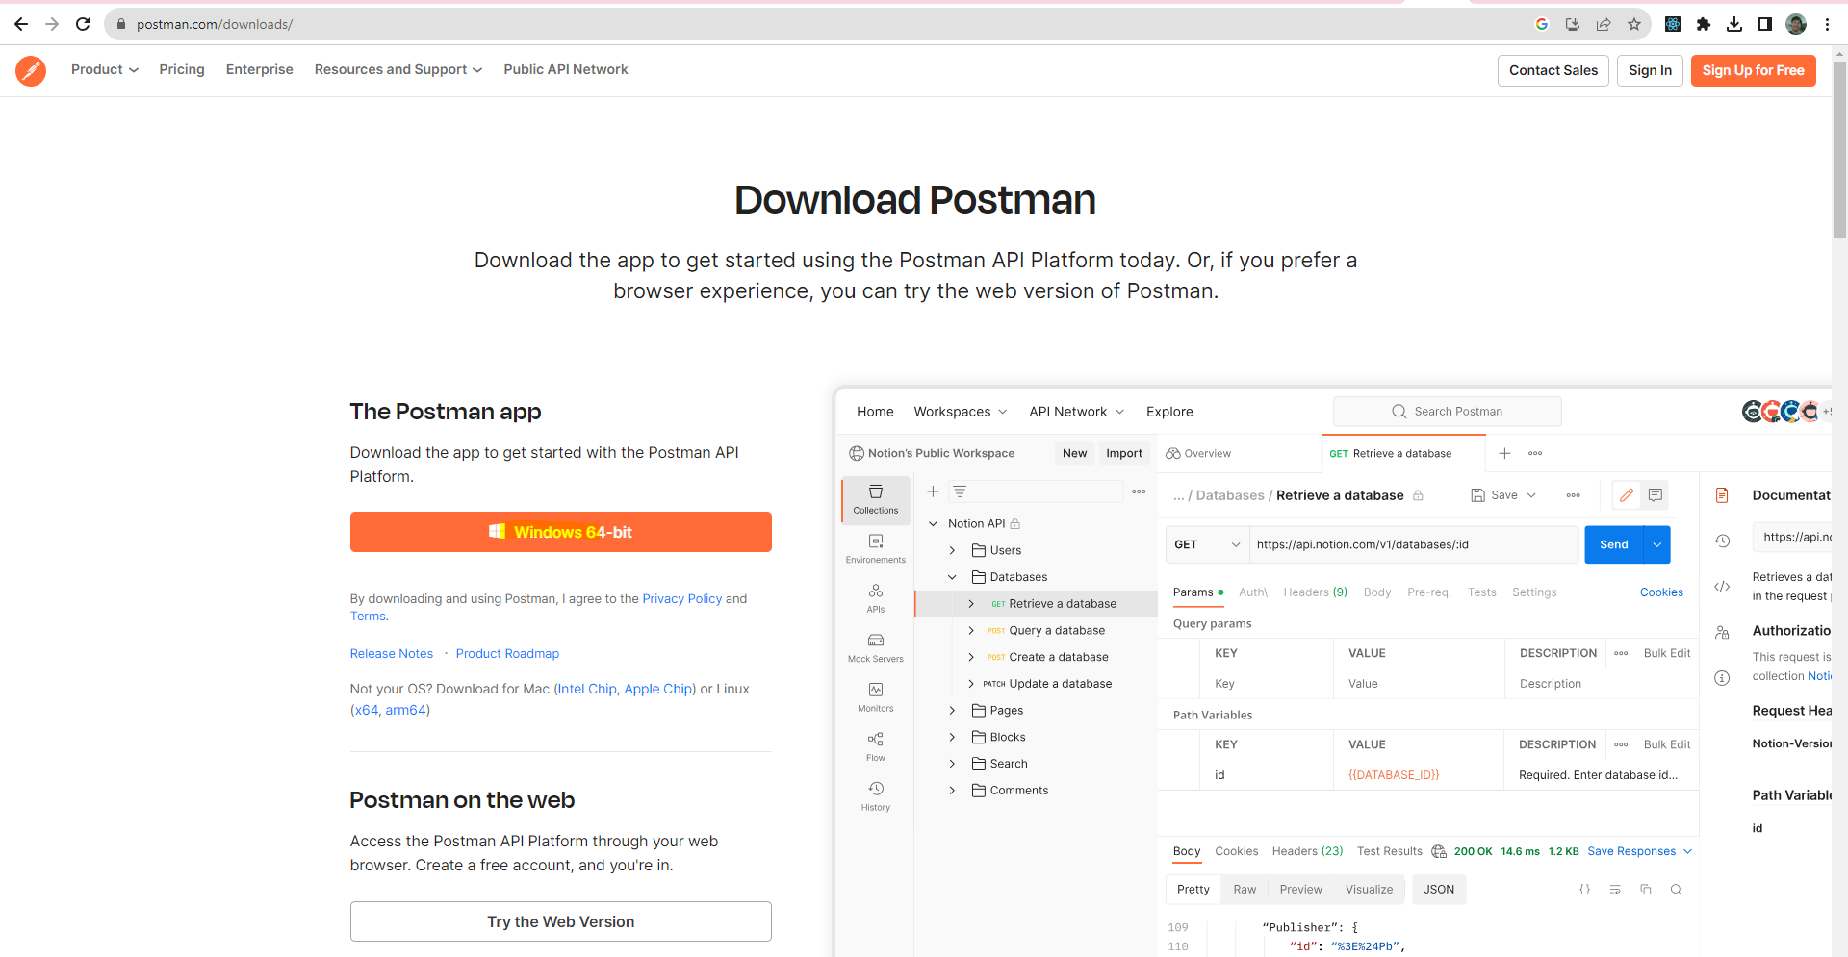

5. Import collection from source : /postman-collection/bookstore.postman_collection.json

